Multi-Source Semantic Evidence Fusion for Long-Tail Object Detection Using Vision Language Models

Master’s Thesis

Submitted by:
Haripriya Chalicheemala
MSc Software Engineering
University of Europe for Applied Sciences

First Supervisor: Prof Dr. Raja Hashim Ali Date: 12.06.2026

Table of Contents
Table of Contents
1. Abstract 3
2. Introduction and Background 4
3. Problem Statement 5
4. Research Objectives 6
5. Research Questions 7
6. Theoretical Framework 8
7. Methodology 9
7.1 Dataset Acquisition and Preparation 9
7.2 Data Preprocessing 10
7.3 Semantic Prompt Generation 10
7.4 Feature Extraction Using Vision-Language Models 11
7.5 Semantic Fusion Framework 12
7.6 Experimental Evaluation Procedure 12
7.7 Result Generation and Visualization 14
7.8 Tools and Infrastructure 15
7.9 Methodology Workflow Summary 15
8. Research Timeline 15
9. Expected Contributions 16
10. Experimental Results and Discussion 17
11. References 29
12. Appendix 30

Abstract
This thesis investigates the fusion of multiple semantically related textual prompts as semantically related evidence sources to improve robust detection of long-tail object categories in long-tail object detection. Current Vision Language Models and OVD approaches rely on single textual descriptions or simple ensemble averaging, which often fail to capture the semantic richness and complementarity of synonymous descriptions. We propose a systematic framework grounded in Information Fusion principles that treats multiple prompts as semantically related evidence sources, employing advanced fusion strategies to aggregate conflicting and complementary semantic information while managing uncertainty.

This work addresses six interconnected research questions spanning semantic evidence fusion, fusion strategy optimization, uncertainty and conflict modelling, redundancy-complementarity analysis, prior aware fusion, and robustness and stability across datasets, long-tail category groups, and fusion configurations. The proposed approach is validated on LVIS v1.0 and COCO 2017 datasets using WordNet-derived synonyms. The study evaluates whether multi-source semantic evidence improves recall and AP50-proxy performance over primary-prompt detection, particularly for LVIS long-tail categories. It also analyses the resulting false-positive trade-off, semantic uncertainty, redundancy-complementarity, and the role of LVIS frequency priors in adaptive-threshold recall. The research contributes to both the Information Fusion and Computer Vision communities by formalizing multi-source semantic fusion for object detection and providing a methodologically rigorous framework for evidence aggregation.

Introduction and Background
Object detection in real-world scenarios frequently encounters severe class imbalance, where many object categories have few or no labelled examples. The LVIS dataset demonstrates this challenge: while common classes have thousands of examples, rare categories may have fewer than 10 examples. This long-tail distribution severely degrades the performance of standard deep learning detectors.

Recent advances in Vision Language Models such as CLIP and long-tail object detection methods offer a promising alternative: by leveraging pre-trained semantic embeddings, these models can detect objects without in-domain training examples. However, current approaches treat semantic information simplistically, either using a single textual description per class or averaging embeddings from multiple descriptions without principled fusion strategies.

From an Information Fusion perspective, multiple semantically related prompts can be viewed as semantically related evidence sources whose information content should be carefully fused to maximize detection robustness and accuracy. This shifts the problem from simple ensemble averaging to formal information fusion the disciplined aggregation and combination of data from multiple sources.

Problem Statement
Despite the success of Vision Language Models in zero-shot transfer, current open-vocabulary object detection methods suffer from four critical limitations:
Underutilization of Semantic Information: Existing methods either use a single textual description per class or apply naive ensemble averaging. They do not systematically analyse which semantic prompts contribute complementary versus redundant information.
- Lack of Principled Fusion: There is no established methodology for selecting and combining multiple semantic prompts as semantically related evidence sources. Questions about optimal fusion strategies remain unanswered empirically and theoretically.
- Robustness and Uncertainty: Methods are not designed to quantify or leverage semantic uncertainty and conflict. False positives often arise when prompts disagree, yet existing methods provide limited mechanisms for quantifying semantic uncertainty and conflict as evidence-quality indicators.
- Long-Tail Performance Degradation: While base-class detection remains strong, performance on rare and unseen objects is significantly worse. The interaction between class-frequency priors and semantic fusion is poorly understood.
These limitations constrain the applicability of long-tail object detection to real-world scenarios where accurate detection of rare objects is critical.

Research Objectives
This research pursued the following specific objectives:

- Design a principled information fusion framework that treats multiple semantic prompts as semantically related evidence sources.
- Investigate and compare aggregation methods under varying long-tail conditions.
- Develop methods to quantify and analyse semantic uncertainty and conflict among prompts.
- Analyse the information contribution of individual prompts and identify redundancy-complementarity trade-offs.
- Integrate LVIS class-frequency priors into the semantic fusion framework and evaluate their influence on long-tail recognition performance.
- Evaluate robustness and stability of semantic fusion-based detectors across datasets, long-tail category groups, and fusion configurations.

Research Questions
This thesis will be guided by the following six research questions:
- RQ1 - Semantic Evidence Fusion: How can multiple semantically related textual prompts be fused as semantically related evidence sources to improve robust detection of long-tail object categories?
- RQ2 - Fusion Strategy Optimality: Which fusion strategies (evidence-level, decision-level, or adaptive fusion) are most effective for aggregating correlated semantic prompts under long-tail and rare-class conditions?
- RQ3 - Uncertainty & Conflict Modelling: How can uncertainty and semantic conflict among synonymous prompts be quantified and used as evidence-quality indicators for false-positive behaviour in long-tail object detection?
- RQ4 - Redundancy vs Complementarity: To what extent do semantic prompts contribute redundant versus complementary information? The study evaluates the contribution of different semantic evidence sources through ablation and redundancy complementarity analysis.
- RQ5 - Prior-Aware Semantic Fusion: How can class-frequency priors be integrated into semantic prompt fusion to improve long-tail recognition performance?
- RQ6 - Framework Stability Across Datasets and Fusion Mechanisms: How stable are semantic fusion-based detectors across datasets, long-tail category groups, and fusion mechanisms?

Theoretical Framework
The theoretical underpinning of this research integrates:
- Information Fusion principles for combining data from multiple sources.
- Vision-Language Model architecture and contrastive learning fundamentals.
- Information-theoretic measures of uncertainty and semantic conflict for evidence-quality analysis.
- Information Theory for measuring redundancy and complementarity.
- Frequency-prior score recalibration for incorporating LVIS long-tail category information into semantic evidence fusion.

7. Methodology
This research adopts an experimental machine learning methodology to investigate the effectiveness of multi-source semantic fusion for improving OWL-ViT-based long-tail object detection.
The proposed approach treats multiple semantic prompts as semantically related evidence sources and integrates them using a structured fusion framework. The methodology is designed to systematically evaluate how semantic diversity, fusion strategies, and uncertainty modelling influence detection performance, particularly for long-tail object categories.
The overall workflow of the proposed method is illustrated in Figure 1, while the detailed model architecture is presented in Figure 4.

7.1 Dataset Acquisition and Preparation
The experiments were conducted using two benchmark datasets:

- LVIS v1: Provides a long-tail distribution with 1,203 object categories, including a large proportion of rare classes.
- COCO 2017 Dataset: Used as a comparative evaluation dataset for semantic fusion analysis.
Dataset statistics, including class distribution and imbalance characteristics, are analysed to support long-tail evaluation scenarios. As shown in Figure 2, the dataset contains diverse object categories with complex annotations.

7.2 Data Preprocessing
The preprocessing stage prepares both image and annotation data for model input:
- Images are resized and normalized using ImageNet statistics
- Annotations are parsed to extract bounding boxes and class labels
- Controlled evaluation subsets are constructed from LVIS and COCO validation images for comparative semantic fusion analysis.
This ensures consistency and reproducibility across all experiments.

7.3 Semantic Prompt Generation
To represent each object category with diverse semantic descriptions, multiple prompts are generated using:
- WordNet-based synonyms and semantically related prompt variants
- Manual refinement for semantic clarity
Semantic prompts are generated automatically using WordNet lexical relations, including synonyms and semantically related concepts. These prompts serve as multiple semantic evidence sources for each object category and enable systematic investigation of semantic diversity within the fusion framework.
Each class is associated with 1–10 prompts, enabling the study of prompt diversity and its impact on detection performance.
These prompts are treated as semantically related evidence sources, forming the basis of the proposed fusion framework.

7.4 Feature Extraction using Vision-Language Models

The framework employs OWL-ViT, which combines transformer-based visual representations with text-query embeddings for open-vocabulary object detection.

7.5 Semantic Fusion Framework
The core contribution of this research lies in the implementation of a multi-source semantic fusion framework, as illustrated in Figure 4.
The architecture consists of two parallel streams:
Image Embedding Stream
- Input Image → Image Encoder → Image Features
Text Embedding Stream
- Prompt Generation → Text Encoder → Text Features
These two streams are combined through:
Feature Alignment
- Cosine similarity aligns image and text embeddings
Fusion Module
Multiple fusion strategies are implemented:
- Primary Prompt
- Semantic Evidence
- Adaptive Fusion
- Prior-Aware Fusion
Adaptive fusion applies confidence-aware evidence aggregation to combine prompt-derived semantic scores. Prior-aware fusion further incorporates LVIS frequency priors as a post-hoc score recalibration mechanism for long-tail analysis, supporting analysis of redundancy and semantic conflict. Figure 4 presents the detailed architecture of the proposed semantic fusion model.

7.6 Detection and Output Generation
Semantic evidence scores are aggregated and evaluated using the detections produced by OWL-ViT.
- Object bounding boxes
- Detection confidence scores
- custom AP50-proxy metrics computed on the sampled subset
This stage generates the final detection outputs used for evaluation.

7.7 Experimental Evaluation
A series of controlled experiments are conducted to answer the research questions:
- Analysis of semantic evidence performance across datasets and long-tail category groups.
- Comparison of fusion strategies
- Analysis of semantic conflict and uncertainty
- Evaluation of redundancy and complementarity
- Integration of class-frequency priors
- Framework stability across datasets, long-tail category groups, and fusion mechanisms
Performance is measured using:
- recall
- pair recall
- AP50 proxy
- uncertainty measures
- conflict measures

7.8 Result Visualization
Experimental results are presented through:
- Performance tables
- Line graphs illustrating fusion-strategy behaviour, uncertainty-risk trends, and prior-sensitivity analysis.
Framework-stability and sensitivity plots
These visualizations support quantitative and qualitative analysis of the proposed method.

7.9 Methodology Summary
The complete workflow can be summarized as:
Dataset Preparation
→ Preprocessing
→ Prompt Generation
→ Feature Extraction using OWL-ViT
→ Semantic Fusion
→ Detection
→ Evaluation and Analysis
This structured pipeline enables systematic investigation of semantic fusion strategies for improving long-tail object detection.

8.Research Timeline
- Phase 1 (Months 1-2): Literature review, framework design, data preparation
- Phase 2 (Months 3-6): Fusion strategy development and empirical evaluation (RQ1-RQ4)
- Phase 3 (Months 7-9): Prior integration and robustness evaluation (RQ5-RQ6)
- Phase 4 (Months 10-12): Analysis, writing, and thesis submission

9.Expected Contributions
- Formalizing multi-source semantic fusion as an information fusion problem in object detection.
- Comparing fusion strategies under long-tail distributions.
- Providing a quantitative analysis of semantic uncertainty and conflict as evidence-quality indicators.
- Providing information-theoretic analysis of semantic prompt complementarity.
- Demonstrating LVIS frequency-prior recalibration for analysing long-tail adaptive-threshold recall.
- Establishing framework-stability analysis for semantic fusion mechanisms across datasets, long-tail category groups, and fusion configurations.

10.Experimental Results and Discussion

RQ1: Semantic Evidence Fusion
Question: How can multiple semantically related textual prompts be fused as semantically related evidence sources to improve robust detection of long-tail object categories?
Result summary: Empirical validation that semantic multi-prompt evidence improves recall and AP50-proxy performance relative to primary-prompt detection across LVIS and COCO evaluation subsets.
Figure 1: Semantic Evidence Fusion Framework. Overview of the proposed multi-source fusion architecture. Region proposals are independently embedded with multiple semantic prompts (cup, mug, drinking vessel), generating independent similarity scores that serve as evidence sources. A fusion module aggregates these scores to produce the final detection decision.
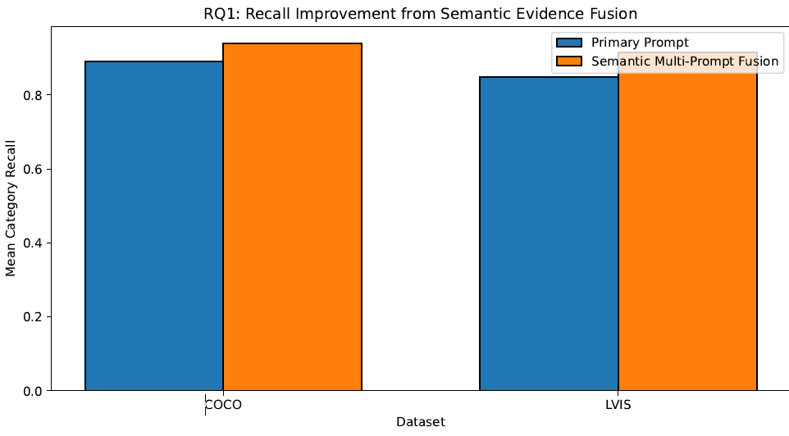
Establishes a structured formulation for treating multiple semantic prompts as semantically related evidence sources. This enables principled aggregation of complementary information beyond conventional single-prompt or averaging approaches.

Figure 2: Analysis of semantic multi-prompt evidence compared with primary-prompt detection across LVIS and COCO evaluation subsets. The results quantify the benefit of aggregating multiple semantic evidence sources relative to single-prompt detection.

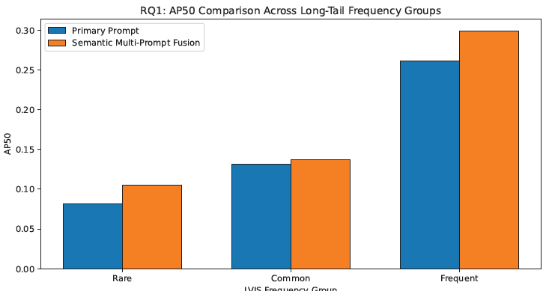

Quantitatively demonstrates the benefit of semantic multi-prompt evidence across evaluation datasets and long-tail category groups. The results provide practical insight into the effectiveness of semantic evidence aggregation.

Table 1. Prompt Fusion Effect on Detection Performance.
Comparison of primary-prompt detection and semantic multi-prompt evidence across COCO and LVIS evaluation subsets. Results demonstrate recall and AP50-proxy gains from semantic multi-prompt evidence on the evaluated COCO and LVIS subsets.

dataset | images | primary_prompt_recall | semantic_prompt_recall | absolute_recall_gain | relative_recall_gain_% | primary_AP50 | semantic_AP50 | AP50_gain | AP50_relative_gain_% | primary_boxes | semantic_boxes | mean_prompts_per_image
COCO | 1000 | 0.8901 | 0.939 | 0 | 5.46 | 0.4 | 0.44 | 0.07 | 19 | 22093 | 35020 | 12.9
LVIS | 1000 | 0.8486 | 0.914 | 0.1 | 7.74 | 0.2 | 0.27 | 0.03 | 15 | 29838 | 47870 | 23.7

Quantitatively demonstrates the benefit of semantic multi-prompt evidence relative to primary-prompt detection. The results provide actionable insights for selecting prompt configurations in real-world systems.

Table 2: LVIS frequency-group semantic evidence summary. The table reports semantic pair recall, fusion scores, prompt-hit statistics, and AP50-proxy changes across rare, common, and frequent LVIS groups.

frequency_group | frequency_code | gt_pairs | semantic_detected_pairs | semantic_pair_recall | mean_max_fusion_score | mean_adaptive_fusion_score | mean_prompt_hits | primary_AP50 | semantic_AP50 | AP50_gain | AP50_relative_gain_%
Rare | r | 331 | 254 | 0.77 | 0.18 | 0.1289 | 6.63 | 0.082 | 0.1 | 0.02 | 29
Common | c | 266 | 232 | 0.87 | 0.241 | 0.1637 | 11.9 | 0.132 | 0.1 | 0.01 | 4.3
Frequent | f | 3535 | 3287 | 0.93 | 0.33 | 0.2165 | 12 | 0.262 | 0.3 | 0.04 | 14
This supports its applicability in long-tail recognition scenarios.
This supports the effectiveness of treating semantic prompts as complementary evidence sources.

RQ2: Fusion Strategy Optimality
Question: Which fusion strategies (evidence-level, decision-level, or adaptive fusion) are most effective for aggregating correlated semantic prompts under long-tail and rare-class conditions?
Result summary: Comparative analysis of fusion strategies showing how different aggregation rules affect semantic evidence scores and threshold sensitivity. Max Fusion provides the highest mean evidence score, while Adaptive Fusion provides a more selective confidence-aware aggregation behaviour.

Figure 3: Fusion Strategy Ranking by Mean Evidence Score. The figure compares fusion strategies using evidence-score statistics rather than official detector superiority.
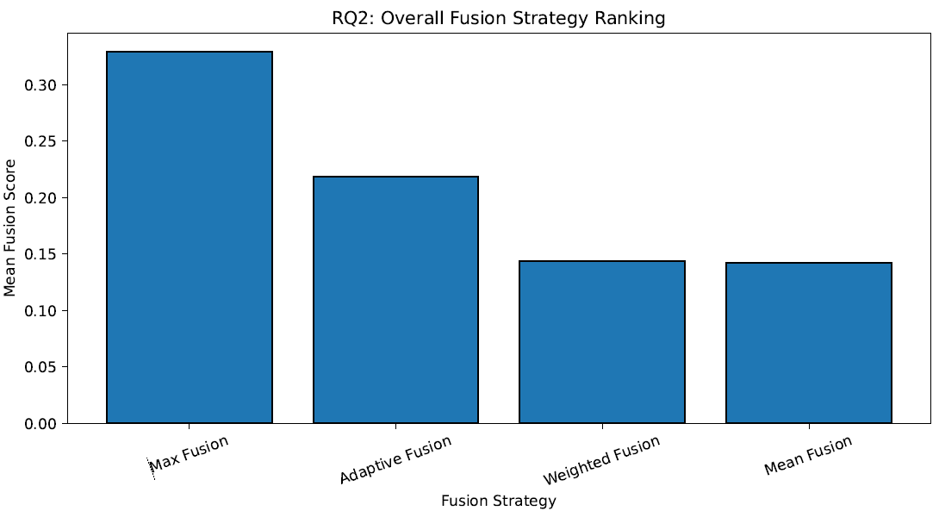
Illustrates evidence-score differences across fusion strategies. The analysis shows that Max Fusion gives the highest mean evidence score, while Adaptive Fusion provides more selective threshold behaviour.

Figure 4: Fusion Strategy Threshold Sensitivity. The figure shows how score-based fusion strategies behave across decision thresholds. 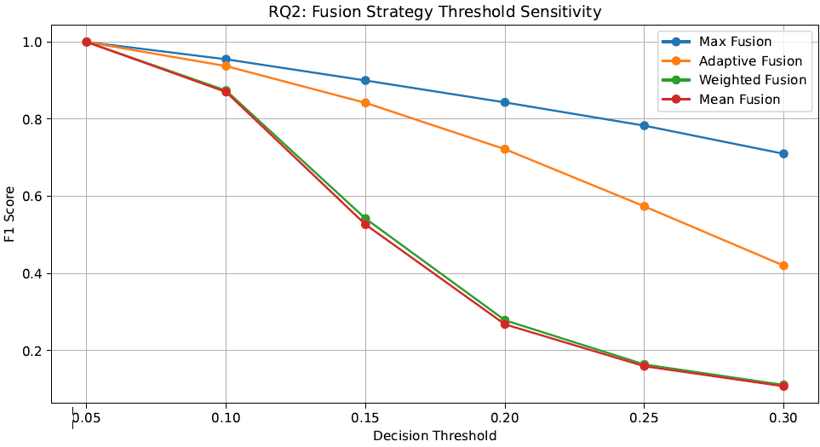
Shows threshold sensitivity of fusion strategies based on evidence-score behaviour. This enhances interpretability and reliability of prediction scores.

Table 3: Fusion Strategy Performance Comparison. Direct comparison of fusion strategies.
Max Fusion achieves the highest mean evidence score, while Adaptive Fusion provides a more selective confidence-aware aggregation profile. These rankings describe evidence-score behaviour and should not be interpreted as definitive detector superiority.

strategy | mean_score | median_score | std_score | rare_mean | common_mean | frequent_mean | overall_rank
Max Fusion | 0.329204 | 0.30392 | 0.218444 | 0.179701 | 0.24055 | 0.330188 | 1
Adaptive Fusion | 0.218371 | 0.206139 | 0.138057 | 0.128916 | 0.163712 | 0.216521 | 2
Weighted Fusion | 0.143601 | 0.127527 | 0.105757 | 0.094947 | 0.111739 | 0.139498 | 3
Mean Fusion | 0.141965 | 0.125931 | 0.104762 | 0.094677 | 0.111142 | 0.137694 | 4

Provides a comprehensive comparison of fusion strategies, comparing fusion strategies according to evidence-score statistics and threshold behaviour. This serves as a benchmark for future model design.

Table 4: Fusion Strategy Statistics Across LVIS Frequency Groups.

The table reports score statistics and detected-pair recall for each fusion strategy across rare, common, and frequent LVIS categories.

frequency_group | frequency_code | strategy | gt_pairs | mean_fusion_score | median_fusion_score | std_fusion_score | semantic_detected_pair_recall | frequency_rank
Common | c | Max Fusion | 266 | 0.2405 | 0.2113 | 0.1735 | 0.8722 | 1
Common | c | Adaptive Fusion | 266 | 0.1637 | 0.1566 | 0.1029 | 0.8722 | 2
Common | c | Weighted Fusion | 266 | 0.1117 | 0.1094 | 0.0646 | 0.8722 | 3
Common | c | Mean Fusion | 266 | 0.1111 | 0.107 | 0.0644 | 0.8722 | 4
Frequent | f | Max Fusion | 3535 | 0.3302 | 0.309 | 0.2103 | 0.9298 | 1
Frequent | f | Adaptive Fusion | 3535 | 0.2165 | 0.2072 | 0.1269 | 0.9298 | 2
Frequent | f | Weighted Fusion | 3535 | 0.1395 | 0.1264 | 0.0898 | 0.9298 | 3
Frequent | f | Mean Fusion | 3535 | 0.1377 | 0.1253 | 0.0888 | 0.9298 | 4
Rare | r | Max Fusion | 331 | 0.1797 | 0.1493 | 0.1586 | 0.7674 | 1
Rare | r | Adaptive Fusion | 331 | 0.1289 | 0.1189 | 0.1023 | 0.7674 | 2
Rare | r | Weighted Fusion | 331 | 0.0949 | 0.0945 | 0.0728 | 0.7674 | 3
Rare | r | Mean Fusion | 331 | 0.0947 | 0.0946 | 0.0725 | 0.7674 | 4

Demonstrates how fusion strategies differ in score distribution and recall behaviour across LVIS frequency groups. This supports the feasibility of deploying advanced fusion mechanisms in practice.

This supports the effectiveness of treating semantic prompts as complementary evidence sources.

RQ3: Uncertainty & Conflict Modelling
Question: How can uncertainty and semantic conflict among synonymous prompts be quantified and used as evidence-quality indicators for false-positive behaviour in long-tail object detection?
Result summary: Quantitative analysis showing the relationship between semantic uncertainty, semantic conflict, and AP50 false-positive behaviour.
Figure 5: Dataset-level false-positive rate across uncertainty risk bins. The figure shows that higher semantic uncertainty is associated with increased AP50 false-positive behaviour. 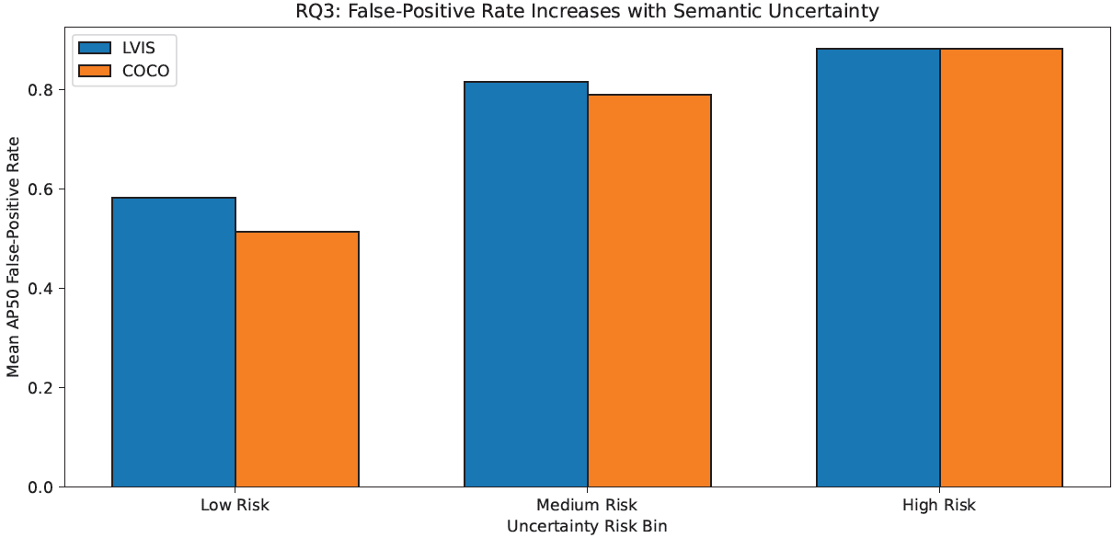
Visualizes areas of agreement and disagreement among semantic prompts, enabling better understanding of model uncertainty. This supports more informed decision-making in ambiguous scenarios.

Figure 6: Relationship between semantic conflict score and AP50 false-positive count. The scatter plot supports the use of conflict as an evidence-quality indicator. 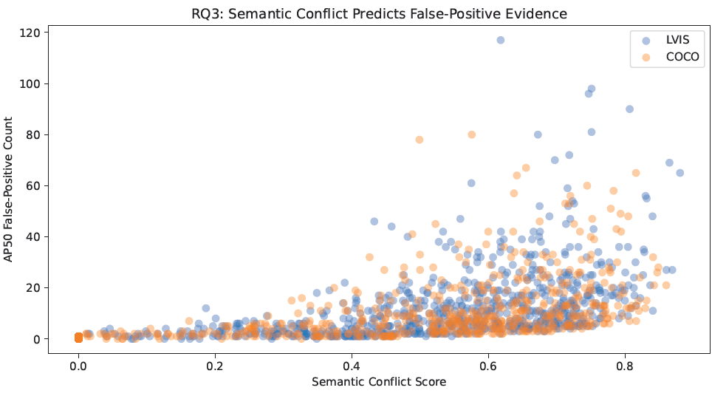

Shows that higher semantic conflict is associated with increased AP50 false-positive evidence, supporting conflict as an evidence-quality indicator.
Table 5: Dataset-level uncertainty, conflict, and false-positive risk summary.

dataset | gt_pairs | semantic_detected_pairs | semantic_pair_recall | mean_entropy | mean_conflict | mean_variation | mean_reliability | mean_uncertainty_risk | mean_fp_risk_proxy | total_TP_AP50 | total_FP_AP50 | mean_FP_rate_AP50 | mean_prompt_count
COCO | 3217 | 2982 | 0.927 | 0.718 | 0.449 | 0.6 | 0.104 | 0.6 | 1.79 | 5108 | 29912 | 0.68 | 10.89
LVIS | 4132 | 3773 | 0.913 | 0.742 | 0.443 | 0.5 | 0.087 | 0.6 | 1.76 | 6518 | 41352 | 0.69 | 11.59

Shows that semantic uncertainty and conflict are associated with false-positive behaviour. These results motivate conflict-aware reliability analysis rather than proving direct false-positive reduction.
Table 6: Uncertainty-risk bin analysis showing how false-positive behaviour changes across low-, medium-, and high-risk evidence groups.

dataset | uncertainty_bin | pairs | mean_entropy | mean_conflict | mean_variation | mean_reliability | mean_uncertainty_risk | mean_fp_risk_proxy | total_TP_AP50 | total_FP_AP50 | mean_FP_rate_AP50 | mean_prompt_count
COCO | Low Risk | 993 | 0.577 | 0.19 | 0.24 | 0.17 | 0.36 | 0.4 | 1094 | 2186 | 1 | 3.303
COCO | Medium Risk | 976 | 0.886 | 0.54 | 0.63 | 0.09 | 0.7 | 1.9 | 2128 | 10438 | 1 | 12.88
COCO | High Risk | 1013 | 0.861 | 0.72 | 0.92 | 0.08 | 0.83 | 3.5 | 1886 | 17288 | 1 | 18.93
LVIS | Low Risk | 1259 | 0.658 | 0.2 | 0.24 | 0.12 | 0.4 | 0.4 | 1369 | 3199 | 1 | 3.628
LVIS | Medium Risk | 1275 | 0.904 | 0.54 | 0.59 | 0.09 | 0.7 | 1.9 | 2706 | 15875 | 1 | 14.57
LVIS | High Risk | 1239 | 0.877 | 0.71 | 0.88 | 0.08 | 0.82 | 3.5 | 2443 | 22278 | 1 | 19.95

Provides quantitative evidence that false-positive behaviour increases from low-risk to high-risk uncertainty groups across LVIS and COCO.
This supports the effectiveness of treating semantic prompts as complementary evidence sources.

RQ4: Redundancy vs Complementarity
Question: To what extent do semantic prompts contribute redundant versus complementary information for long-tail object detection?
Result summary: Prompt-ablation and redundancy-complementarity analysis quantifying the contribution of different semantic evidence sources.
Figure 7: Prompt-type ablation analysis showing the recall drop when each semantic evidence source is removed.
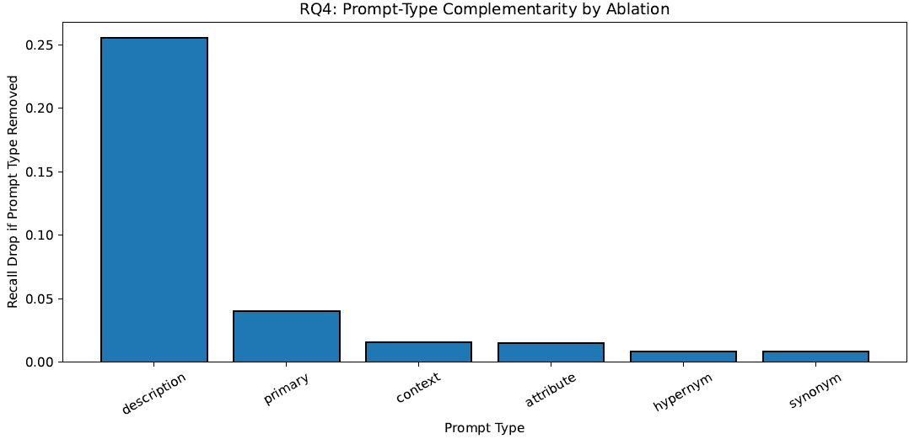

Reveals the relationship between semantic redundancy and marginal performance gain. This insight helps avoid inefficient use of redundant prompts.
Figure 8: Long-tail redundancy and complementarity analysis across LVIS frequency groups.
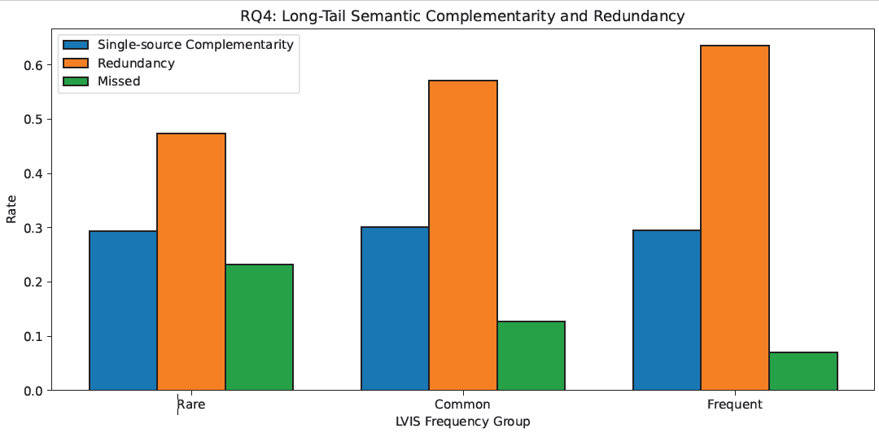
Shows how redundancy, single-source complementarity, and missed-pair rates vary across LVIS rare, common, and frequent groups.
Table 7: Prompt ablation, complementarity, redundancy, and statistical contribution analysis.

prompt_type | gt_pairs | semantic_threshold | pairs_with_prompt_evidence | coverage_rate | unique_pairs | shared_pairs | unique_contribution_rate | redundant_contribution_rate | recall_all_prompts | recall_without_prompt | recall_drop_if_removed | relative_drop_% | mcnemar_stat | mcnemar_p_value | significant_at_0.05 | mcnemar_effect | importance_rank
description | 7349 | 0.05 | 4176 | 0.5682 | 1875 | 2301 | 0.2551 | 0.3131 | 0.9192 | 0.664 | 0.2551 | 27.76 | 1873.001 | 0 | TRUE | 1 | 1
primary | 7349 | 0.05 | 2994 | 0.4074 | 297 | 2697 | 0.0404 | 0.367 | 0.9192 | 0.8788 | 0.0404 | 4.4 | 295.0034 | 4.04E-66 | TRUE | 1 | 2
context | 7349 | 0.05 | 2893 | 0.3937 | 116 | 2777 | 0.0158 | 0.3779 | 0.9192 | 0.9034 | 0.0158 | 1.72 | 114.0086 | 1.30E-26 | TRUE | 1 | 3
attribute | 7349 | 0.05 | 2379 | 0.3237 | 110 | 2269 | 0.015 | 0.3087 | 0.9192 | 0.9042 | 0.015 | 1.63 | 108.0091 | 2.68E-25 | TRUE | 1 | 4
hypernym | 7349 | 0.05 | 852 | 0.1159 | 61 | 791 | 0.0083 | 0.1076 | 0.9192 | 0.9109 | 0.0083 | 0.9 | 59.0164 | 1.56E-14 | TRUE | 1 | 5
synonym | 7349 | 0.05 | 1342 | 0.1826 | 60 | 1282 | 0.0082 | 0.1744 | 0.9192 | 0.911 | 0.0082 | 0.89 | 58.0167 | 2.60E-14 | TRUE | 1 | 6

Quantifies prompt-type contribution using ablation, unique-pair contribution, redundant-pair contribution, recall drop, and statistical testing.
Table 8: Dataset-level and LVIS frequency-level redundancy-complementarity summary.

level | group | frequency_code | semantic_threshold | gt_pairs | detected_pairs | all_prompt_recall | single_source_pairs | redundant_pairs | missed_pairs | single_source_rate | redundancy_rate | miss_rate | mean_prompt_types_hit
Dataset | COCO | NA | 0.05 | 3217 | 2982 | 0.9 | 1300 | 1682 | 235 | 0.4 | 0.52 | 0.07 | 1.8
Dataset | LVIS | NA | 0.05 | 4132 | 3773 | 0.9 | 1219 | 2554 | 359 | 0.3 | 0.62 | 0.09 | 2.14
LVIS Frequency | Rare | r | 0.05 | 331 | 254 | 0.8 | 97 | 157 | 77 | 0.29 | 0.47 | 0.23 | 1.57
LVIS Frequency | Common | c | 0.05 | 266 | 232 | 0.9 | 80 | 152 | 34 | 0.3 | 0.57 | 0.13 | 1.99
LVIS Frequency | Frequent | f | 0.05 | 3535 | 3287 | 0.9 | 1042 | 2245 | 248 | 0.29 | 0.64 | 0.07 | 2.21

Summarizes redundancy and complementarity patterns across datasets and LVIS frequency groups.

This supports the effectiveness of treating semantic prompts as complementary evidence sources.

RQ5: Prior-Aware Semantic Fusion
Question: How can class-frequency priors be integrated into semantic prompt fusion to improve long-tail recognition performance?
Result summary: Comparative analysis of LVIS frequency-prior integration showing how prior-aware recalibration affects recall across rare, common, and frequent categories across rare, common, and frequent categories.
Figure 9: Prior-aware fusion recall comparison relative to Adaptive Fusion across LVIS rare, common, and frequent groups.
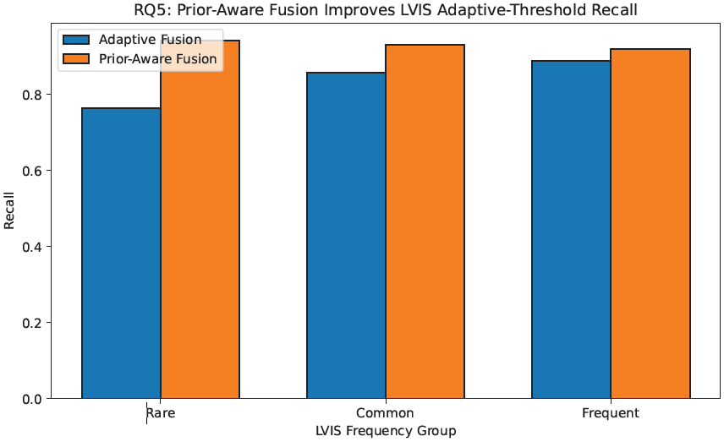
Illustrates the integration of prior knowledge with semantic evidence in a unified framework. This illustrates how LVIS frequency priors can recalibrate adaptive semantic evidence for long-tail analysis.
Figure 10: Sensitivity of overall and rare-category recall to rare-class prior weight.
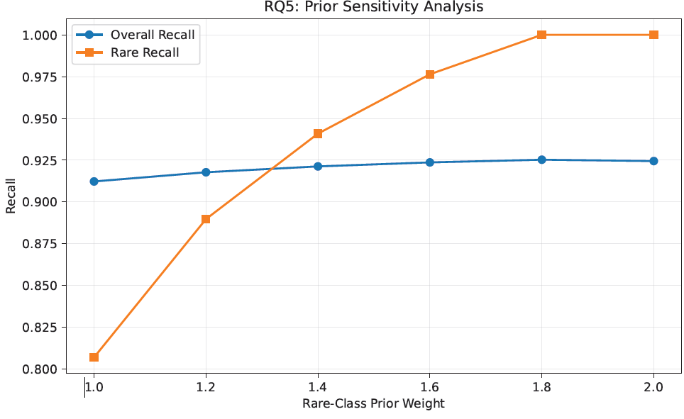

Visualizes the sensitivity of overall and rare-category recall to prior-weight selection, identifying practical operating points. This aids in selecting balanced models for different application needs.

Table 9: LVIS long-tail prior-aware recall gain relative to adaptive fusion.
frequency_group | frequency_code | gt_pairs | evaluation_target | threshold | adaptive_recall | prior_aware_recall | absolute_gain | relative_gain_%
Rare | r | 331 | was_detected | 0.1 | 0.764 | 0.941 | 0.18 | 23.2
Common | c | 266 | was_detected | 0.1 | 0.858 | 0.931 | 0.07 | 8.54
Frequent | f | 3535 | was_detected | 0.1 | 0.888 | 0.919 | 0.03 | 3.49

Shows that prior-aware score recalibration improves LVIS adaptive-threshold recall across rare, common, and frequent groups, with the largest relative gain for rare categories.

Table 10: Fusion method comparison within the LVIS prior-aware analysis setting. This ranking is restricted to the LVIS prior-aware analysis setting and should not be interpreted as overall superiority relative to Semantic Evidence.

method | evaluation_target | threshold | overall_recall | mean_score | median_score | std_score | rank
Prior-Aware Fusion | was_detected | 0.1 | 0.921 | 0.24 | 0.229 | 0.15 | 1
Max Fusion | was_detected | 0.1 | 0.911 | 0.312 | 0.287 | 0.21 | 2
Adaptive Fusion | was_detected | 0.1 | 0.878 | 0.206 | 0.198 | 0.13 | 3

Shows sensitivity of prior-aware recall to the rare-class prior weight. Moderate rare-class weighting improves rare recall while excessive weighting reduces overall recall.
This supports the effectiveness of treating semantic prompts as complementary evidence sources.

RQ6: Framework Stability Across Datasets and Fusion Mechanisms
Question: How stable are semantic fusion-based detectors across datasets, long-tail category groups, and fusion mechanisms?
In this research, RQ6 is operationalized as framework-level stability across datasets, long-tail category groups, and fusion mechanisms.
Result summary: Validation that semantic fusion mechanisms are evaluated for stability across datasets, long-tail category groups, and fusion strategies, providing insight into robustness under varying semantic evidence conditions.
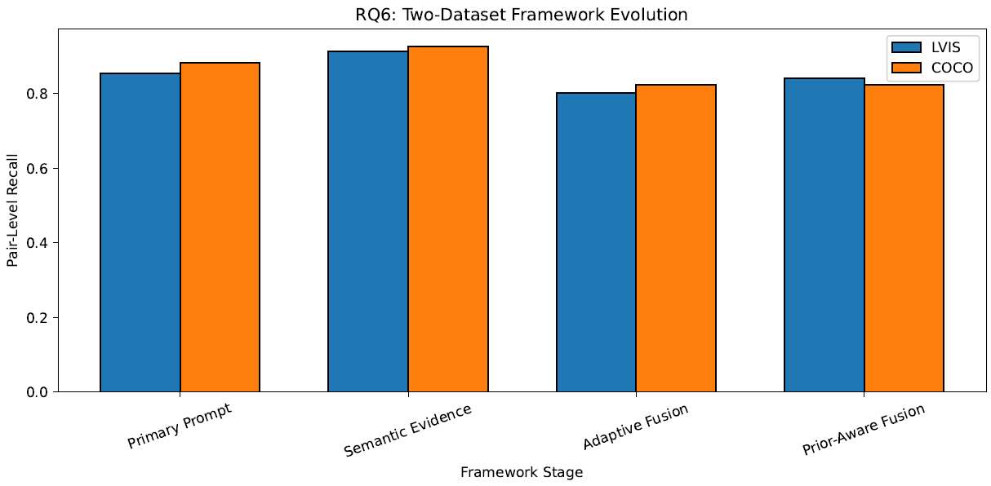
Figure 11: Two-dataset framework evolution across Primary Prompt, Semantic Evidence, Adaptive Fusion, and Prior-Aware Fusion.
The framework comparison illustrates how different semantic evidence aggregation mechanisms influence recall and evidence scores across datasets and long-tail frequency groups.
Figure 12: Framework evolution across COCO and LVIS rare/common/frequent groups.
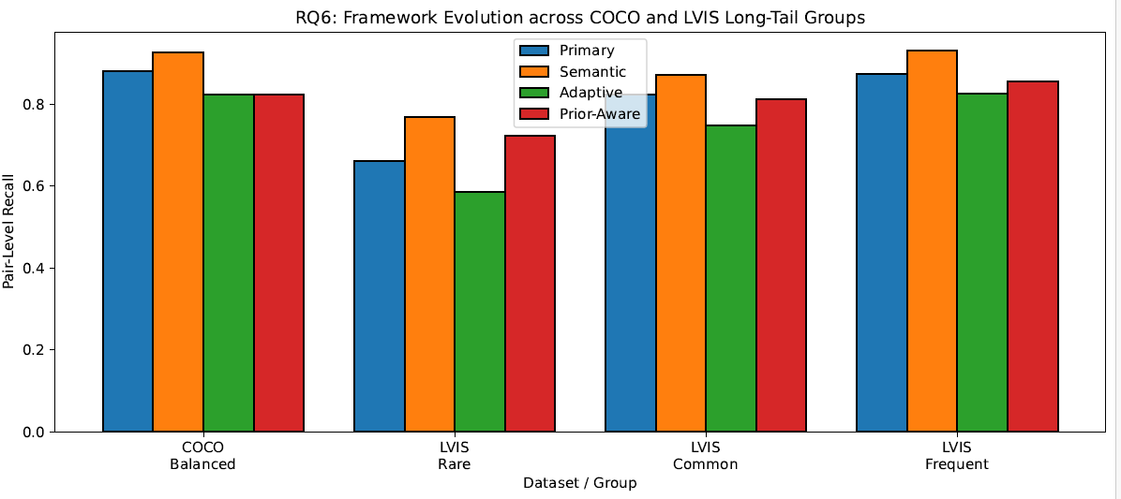
The framework comparison illustrates how different semantic evidence aggregation mechanisms influence recall and evidence scores across datasets and long-tail frequency groups.
Table 11: Dataset-level framework evolution across fusion mechanisms.
dataset | method | gt_pairs | recall | mean_score | detected_pairs
LVIS | Primary Prompt | 4132 | 0.8538 | 0.2312 | 3528
LVIS | Semantic Evidence | 4132 | 0.9131 | 0.3124 | 3773
LVIS | Adaptive Fusion | 4132 | 0.8015 | 0.2061 | 3312
LVIS | Prior-Aware Fusion | 4132 | 0.8412 | 0.2396 | 3476
COCO | Primary Prompt | 3217 | 0.8816 | 0.236 | 2836
COCO | Semantic Evidence | 3217 | 0.927 | 0.3508 | 2982
COCO | Adaptive Fusion | 3217 | 0.8231 | 0.2341 | 2648
COCO | Prior-Aware Fusion | 3217 | 0.8231 | 0.2341 | 2648

The framework comparison illustrates how different semantic evidence aggregation mechanisms influence recall and evidence scores across datasets and long-tail frequency groups.

Table 12: Group-level framework evolution across COCO and LVIS long-tail frequency groups.
dataset | group | frequency_code | gt_pairs | primary_recall | semantic_recall | adaptive_recall | prior_aware_recall
COCO | Balanced | NA | 3217 | 0.882 | 0.927 | 0.823 | 0.82
LVIS | Rare | r | 331 | 0.662 | 0.767 | 0.586 | 0.72
LVIS | Common | c | 266 | 0.823 | 0.872 | 0.748 | 0.81
LVIS | Frequent | f | 3535 | 0.874 | 0.93 | 0.826 | 0.85

Provides group-level evidence showing that Semantic Evidence achieves the highest overall recall, while Prior-Aware Fusion improves LVIS adaptive-threshold long-tail recall relative to Adaptive Fusion.
Semantic multi-prompt evidence provides the strongest overall recall coverage across LVIS and COCO, while Prior-Aware Fusion improves adaptive-threshold recall within the LVIS setting through frequency-prior score recalibration.

This supports the effectiveness of treating semantic prompts as complementary evidence sources.

11.References

[1] Gupta, A., Dollár, P., and Girshick, R. (2019).
LVIS: A Dataset for Large Vocabulary Instance Segmentation.
Proceedings of the IEEE/CVF Conference on Computer Vision and Pattern Recognition (CVPR), 5356–5364.
[2] Li, X., Wang, W., Wu, L., Chen, S., Hu, X., Li, J., and Tang, J. (2022).
DETIC: Detecting Twenty-thousand Classes using Image-level Supervision.
European Conference on Computer Vision (ECCV), 261–277.
[3] Khaleghi, B., Khamis, A., Karray, F. O., and Razavi, S. N. (2013).
Multisensor Data Fusion: A Review of the State-of-the-Art.
Information Fusion, 14(1), 28–44.
[4] Radford, A., Kim, J. W., Hallacy, C., Ramesh, A., Goh, G., Agarwal, S., Sastry, G., Askell, A., Mishkin, P., Clark, J., Krueger, G., and Sutskever, I. (2021).
Learning Transferable Visual Models From Natural Language Supervision.
Proceedings of the International Conference on Machine Learning (ICML), 8748–8763.
[5] Minderer, M., Gritsenko, A., Stone, A., Neumann, M., and Houlsby, N. (2022).
Simple Open-Vocabulary Object Detection with Vision Transformers.
European Conference on Computer Vision (ECCV), 728–755.
[6] Bansal, A., Sikka, K., Sharma, G., Chellappa, R., and Divakaran, A. (2018).
Zero-Shot Object Detection.
Proceedings of the European Conference on Computer Vision (ECCV), 384–400.
[7] Miller, G. A. (1995).
WordNet: A Lexical Database for English.
Communications of the ACM, 38(11), 39–41.

[8] Brown, T., Mann, B., Ryder, N., Subbiah, M., Kaplan, J. D., Dhariwal, P., et al. (2020).
Language Models are Few-Shot Learners.
Advances in Neural Information Processing Systems (NeurIPS), 33, 1877–1901.
[9] Murphy, C. K. (2000).
Combining Belief Functions When Evidence Conflicts.
Decision Support Systems, 29(1), 1–9.
[10] Liu, Z., Pan, Q., Dezert, J., and Han, J. (2017).
A New Belief Entropy for Dempster–Shafer Evidence Theory.
Information Fusion, 37, 99–116.
[11] Denœux, T. (2019).
Decision-Making with Belief Functions: A Review.
Information Fusion, 49, 87–110.
[12] Zang, Y., Li, W., Yang, K., and Luo, P. (2022).
Open-Vocabulary Object Detection with Vision-Language Models.
IEEE Transactions on Pattern Analysis and Machine Intelligence (TPAMI).
[13] Minderer, M., Gritsenko, A., Stone, A., and Houlsby, N. (2022).
Scaling Open-Vocabulary Object Detection.
Advances in Neural Information Processing Systems (NeurIPS).
[14] Wang, J., Chen, K., Xu, R., Liu, Z., Loy, C. C., and Lin, D. (2021).
Seesaw Loss for Long-Tailed Instance Segmentation.
Proceedings of the IEEE/CVF Conference on Computer Vision and Pattern Recognition (CVPR), 9695–9704.
[15] Zhang, Y., Kang, B., Hooi, B., Yan, S., and Feng, J. (2021).
Deep Long-Tailed Learning: A Survey.
IEEE Transactions on Pattern Analysis and Machine Intelligence (TPAMI).

12.Appendix

A.1 Experimental Configuration
The proposed framework was evaluated using controlled subsets of the LVIS and COCO validation datasets. The evaluation consisted of 1000 LVIS validation images and 1000 COCO validation images selected for comparative semantic fusion analysis. All experiments were conducted using the OWL-ViT-based object detection framework. The study focused on semantic evidence generation, evidence aggregation, uncertainty analysis, redundancy complementarity analysis, prior-aware fusion, and framework-level evaluation.
A.2 Semantic Prompt Construction
Semantic evidence was generated from multiple prompt types derived from category names and WordNet-based semantic resources. Prompt variants included primary category names, synonyms, descriptive phrases, attributes, contextual descriptions, and semantically related prompt variants. These prompt groups were used to construct heterogeneous semantic evidence sources for open-vocabulary object detection.
A.3 Fusion Strategies
The framework evaluated multiple evidence aggregation strategies:
• Primary Prompt Detection
• Semantic Evidence Fusion
• Max Fusion
• Mean Fusion
• Adaptive Fusion
• Prior-Aware Fusion
These strategies were compared using pair-level recall, semantic evidence scores, uncertainty measures, redundancy–complementarity statistics, and AP50/AP75 proxy metrics.
A.4 Evaluation Metrics
The study reports the following metrics:
• Image-level category recall
• Pair-level recall
• AP50 proxy metric
• AP75 proxy metric
• Precision at AP50 matching
• Semantic evidence score statistics
• Entropy-based uncertainty measures
• Semantic conflict measures
• Redundancy and complementarity indicators
AP50 and AP75 are custom IoU-based proxy metrics computed on the sampled evaluation subsets and should not be interpreted as official COCO or LVIS benchmark mAP values.
A.5 Research Question Outputs
RQ1 evaluated semantic evidence coverage and recall improvement over primary-prompt detection.
RQ2 compared evidence aggregation strategies using evidence-score behaviour and threshold sensitivity.
RQ3 quantified uncertainty, semantic conflict, and their relationship with false-positive behaviour.
RQ4 analysed redundancy and complementarity among semantic evidence sources.
RQ5 evaluated LVIS frequency-prior score recalibration for long-tail adaptive-threshold recall analysis.
RQ6 evaluated framework-level stability across datasets, long-tail category groups, and fusion mechanisms.
A.6 Limitations
The experiments were conducted on controlled subsets of the LVIS and COCO validation datasets rather than full benchmark evaluations.
Semantic multi-prompt evidence improves recall coverage but also increases false-positive behaviour.
Prior-aware fusion is evaluated only as a frequency-aware score recalibration mechanism for LVIS long-tail analysis.
AP50 and AP75 results represent proxy metrics computed on the evaluation subsets and are not official benchmark mAP scores.
Explicit adversarial prompt perturbation experiments and benchmark-scale evaluations are considered future work.
A.7 Supplementary Materials
The supplementary package includes:
• Final notebook implementation
• RQ1–RQ6 result tables
• RQ1–RQ6 figures
• Semantic prompt resources
• Validation outputs
• Reproducibility files required to regenerate the reported results

